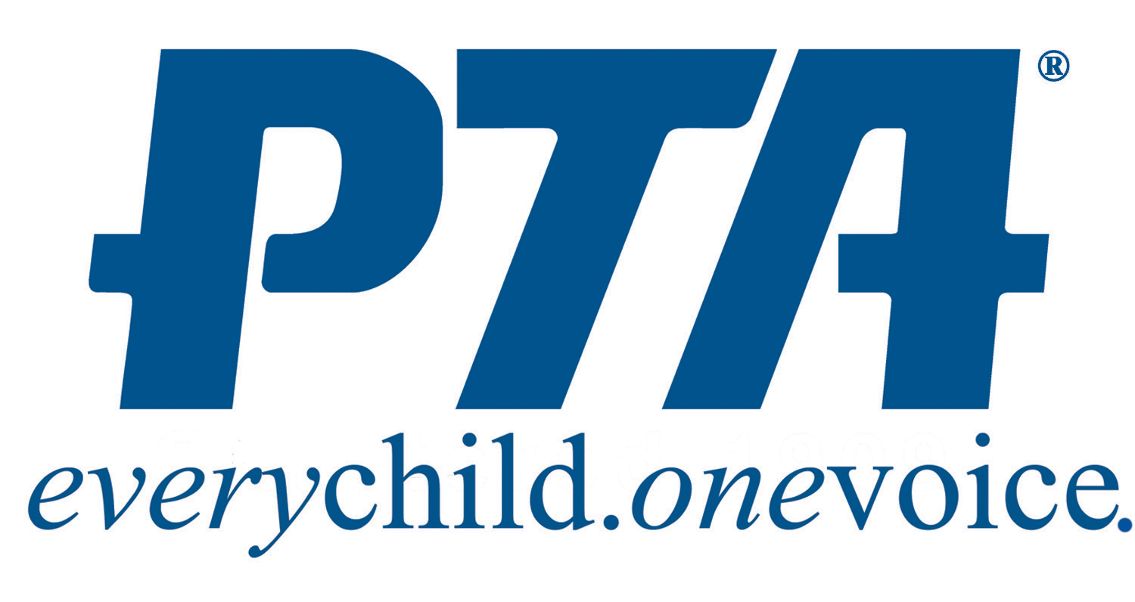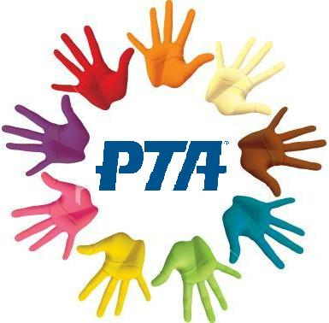

* Expand and strengthen family engagement.
* Fight for access to well-rounded curricula, equity protections for disadvantaged populations, and accountability to parents and the community.
* Ensure student access to highly qualified teachers.
* Increase federal funding for Individuals with Disabilities Education Act (IDEA) by a minimum of an additional 3% this year, to move towards the commitment made by Congress to authorize federal funding of 40% of IDEA costs.
* Support federal programs and policies that promote safe routes to school, prevent bullying, and protect children from gun violence

# At the Federal level, we will organize to:

Capistrano Unified Council PTSA

23,000 members

### Legislative Agenda

### 2018-2019

# At the State level, we will advocate for and support:

* Sufficient funding to repair, modernize, and construct needed school facilities.
* A stable school finance system without relying on local fundraising.
* Transparency and accountability through Local Control and Accountability Plans.
* Local school districts to have flexibility in decision-making and the allocating of funds, allowing sufficient reserves to support financial stability.
* Improved school attendance through policies that reduce truancy and address chronic absenteeism.
* Access for every student to a full curriculum under the California State Standards, including STEAM and physical education.
* Programs that promote student health and safety, including driving safety.
* Measures to eliminate the opportunity gap.

**CUCPTSA Advocacy**

**Engagement:**

* Opportunities for parent/student participation in budget and policy developments that affect all students. Encourage parent and student participation in review and development of the CUSD Local Control and Accountability Plan.
* Parents, students and community participation as public education advocates. Educate parents and the public aboutCUSD schools and the positive impact of strong schools on our communities.
* PTA and CUSD partnerships with local businesses and the community toenhance student achievement.
* Programs in our schools, communities and the district that promote diversity and inclusion.
* Educate local stake holders, parents, community members, elected representatives regarding school funding for facilities and programs.

**Student Achievement:**

* Increased State funding for smaller class sizes at primary grade levels.
* Teacher and student resources around the California state standards, including those that promote district-wide success in the Smarter Balance Assessments.
* Continued and expanded access to visual and performing arts programs for all students and promote imbedding the arts into all grade level curriculums.
* High school curriculum, including academic electives and coursework, designed to achieve college and career readiness.
* Equal and consistent site support and access to technology, training and ongoing professional development.
* Effective guidance services and programs for secondary students looking toward to post-graduation college and career options.
* Promote programs that develop civic responsibility.

**Facilities and Technology:**

* CUSD to inform the community of the state of facilities and develop plans for modernization, repair, and upgrade of those facilities.
* Implementation of the district’s technology upgrade plan in a timely manner.

**Student Wellness and School Climate:**

* Prioritizing counseling, physical and mental health services, and student support staff at all schools to provide a supportive, nurturing and safe environment for students.
* Programs that support physical fitness and address childhood obesity. Advocate for increased CUSD support of school athletic programs.
* Programs and health curriculum that address the negative affects that media messages about body image have on a majority of adolescent and teen girls.
* Programs that prevent bullying and cyber-bullying. Advocate for education and resources to support targeted students and their families.
* Maintain funding of School Resource Officers and drug and alcohol educationat all middle and high schools.

# At the Local level, we will advocate for and support: